**Step 1: Drawing Basic Shapes With Python Turtle**

1. Create an new Repl by selecting the **“Python with Turtle”** language / environment.

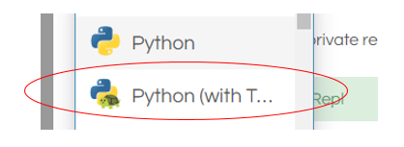

1. Begin all of your turtle programs with the following code to create a “pen”:

import turtle

myPen = turtle.Turtle()

1. Review the following chart for a list of Turtle commands.

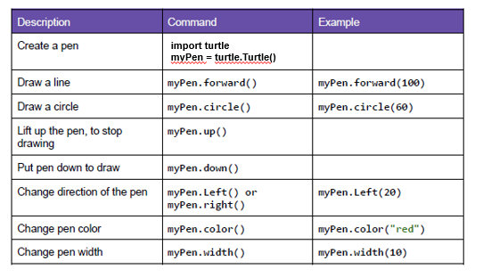

1. Use the following program to draw a red square.

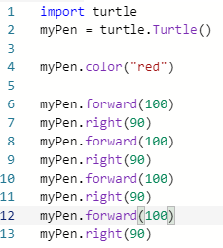

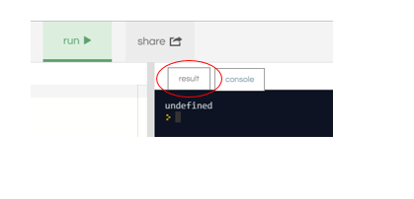

1. Switch to the “Result” window to see the square.
2. Create a program to draw any one of the shapes “b”, ”d”, or “e” shown in the figures below.   
   Provide a listing of your program code.

import turtle

myPen= turtle.Turtle()

myPen.color("white")

myPen.right(45)

myPen.forward(100)

myPen.up

myPen.right(180)

myPen.forward(50)

myPen.right(90)

myPen.forward(50)

myPen.right(180)

myPen.down()

myPen.forward(100)

1. Create a program to draw any one of the shapes “c”, or “f” shown in the figures below.   
   Provide a listing of your program code.
2. import turtle
3. myPen= turtle.Turtle()
4. myPen.color("red")
5. myPen.forward(100)
6. myPen.right(90)
7. myPen.forward(100)
8. myPen.right(90)
9. myPen.forward(100)
10. myPen.right(90)
11. myPen.forward(100)
12. myPen.right(90)
13. myPen.up
14. myPen.right(90)
15. myPen.forward(50)
16. myPen.down
17. myPen.color("blue")
18. myPen.circle(50)

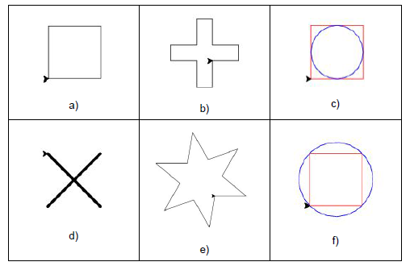

**Step 2: Christmas / Winter Theme Card**

1. Use your creativity to create a card design using Turtle.
   1. The design must have multiple figures.
   2. The design must have at least two different patterns.
   3. You may repeat patterns.
   4. Provide a listing of your program code.
   5. Provide an image of your program result.

import turtle

import random

bg = turtle.Screen()

bg.bgcolor("dark blue")

def draw_circle(turtle, color, size, x, y):

turtle.penup()

turtle.color(color)

turtle.fillcolor(color)

turtle.goto(x,y)

turtle.pendown()

turtle.begin_fill()

turtle.circle(size)

turtle.end_fill()

myPen = turtle.Turtle()

myPen.speed(100)

myPen.penup()

myPen.goto(0,0)

myPen.color("green")

myPen.begin_fill()

myPen.fillcolor("green")

myPen.pensize(8)

myPen.pendown()

myPen.goto(100,0)

myPen.penup()

myPen.end_fill()

myPen.goto(100,0)

myPen.pendown()

myPen.color("green")

myPen.begin_fill()

myPen.fillcolor("green")

myPen.goto(0,75)

myPen.goto(-100,0)

myPen.forward(100)

myPen.goto(125,-65)

myPen.goto(-125,-65)

myPen.goto(0,0)

myPen.penup()

myPen.end_fill()

myPen.goto(0,75)

myPen.pendown()

myPen.color("green")

myPen.begin_fill()

myPen.fillcolor("green")

myPen.goto(50,75)

myPen.goto(0,120)

myPen.goto(-50,75)

myPen.goto(0,75)

myPen.penup()

myPen.end_fill()

myPen.goto(0,-120)

myPen.pendown()

myPen.color("brown")

myPen.begin_fill()

myPen.fillcolor("brown")

myPen.goto(20,-120)

myPen.left(90)

myPen.forward(50)

myPen.left(90)

myPen.forward(40)

myPen.left(90)

myPen.forward(50)

myPen.left(90)

myPen.forward(20)

myPen.penup()

myPen.end_fill()

